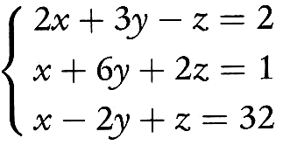

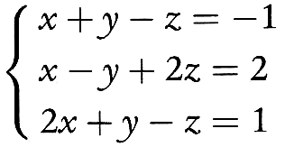

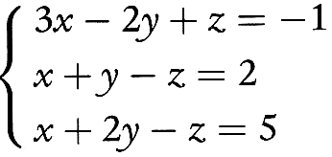

$$\left\{\begin{matrix}x+y+z=1 \\ 2x−y+z=5 \\ x+2y−2z=6\end{matrix}\right.$$

$$\left\{\begin{matrix}x+y+z=1 \\ 3x+z=\text{10} \\ y−2z=0\end{matrix}\right.$$

