Esercitazione di Geometria Analitica

Posiziona sul piano cartesiano i seguenti punti:
$A\left(0;2\right)$
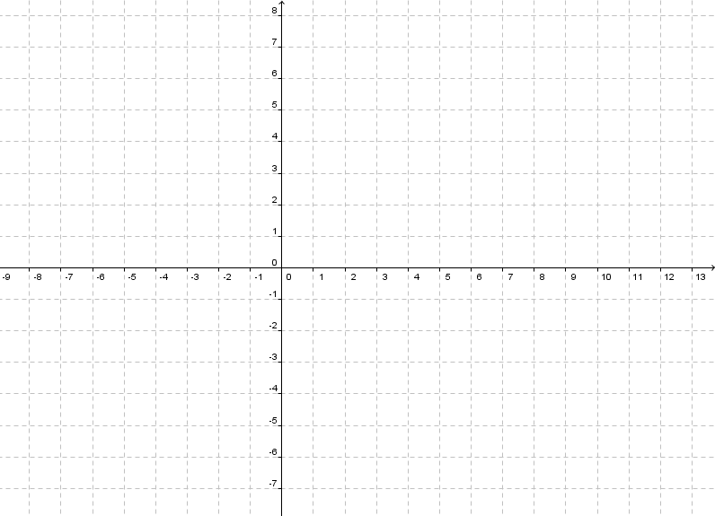

$$B\left(3;0\right)$$
$$C\left(5;3\right)$$
$$D\left(3;5\right)$$
$$E\left(−2;4\right)$$
$$F\left(3;−4\right)$$
$$G\left(−1;−2\right)$$
$$H\left(5;5\right)$$
$$I\left(−3;−3\right)$$
$$L\left(3;−3\right)$$
$$L\left(−4;4\right)$$

Disegna nel piano cartesiano le seguenti rette:
$$x=3$$

$$x=−2$$
$$y=3$$
$$y=−2$$
$$y=3x$$
$$y=−2x$$
$$y=x+2$$
$$y=x−2$$
$$y=−x+2$$
$$y=−x−2$$
$$y=5x−1$$
$$y=\frac{1}{2}x+1$$
Scrivi le seguenti rette in forma implicita:
- $$y=3$$
- $$y=−2$$
- $$y=3x$$
- $$y=−2x$$
- $$y=x+2$$
- $$y=x−2$$
- $$y=−x+2$$
- $$y=−x−2$$
- $$y=5x−1$$
- $$y=\frac{1}{2}x+1$$

Scrivi le seguenti rette in forma esplicita:
- $$−x+y−1=0$$
- $$x+y+4=0$$
- $$3x+4y−1=0$$
- $$−\frac{2}{3}x+y−1=0$$
- $$−\frac{2}{3}x+\frac{4}{5}y−\frac{3}{2}=0$$

