LIMITI – ESERCIZI CON SOLUZIONI

Calcolare il valore dei seguenti limiti:

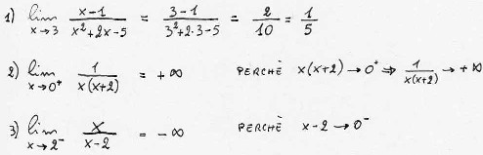
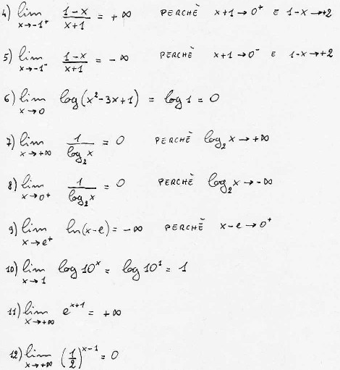
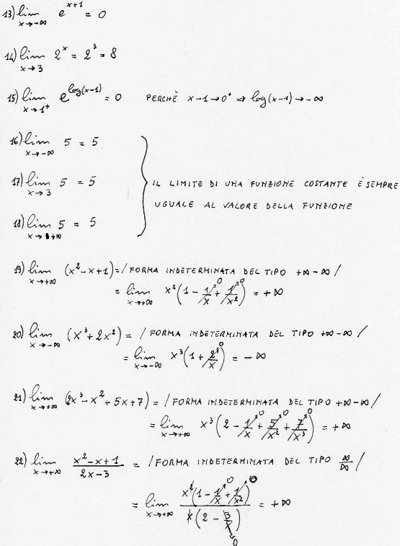
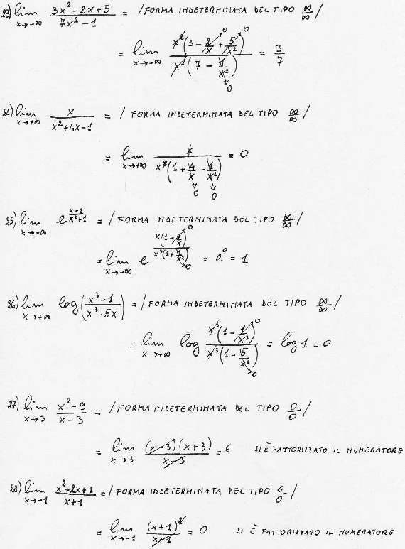
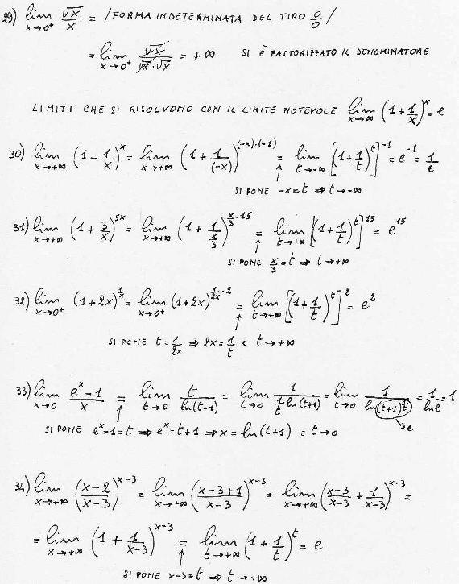
Calcolare il dominio delle seguenti funzioni e i limiti agli estremi del dominio:

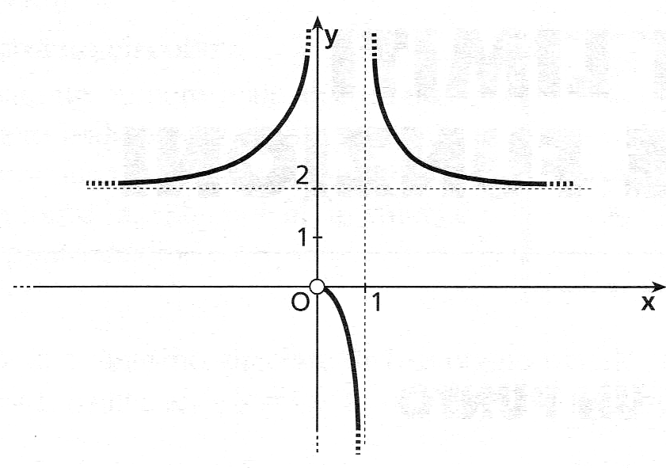 | $$D=\left(−∞;0\right)∪\left(0;1\right)∪\left(1;+∞\right)$$  $$\underset{x→−∞}{\text{lim}}f(x)=2$$  $$\underset{x→0^{−}}{\text{lim}}f(x)\text{=+}∞$$  $$\underset{x→0^{+}}{\text{lim}}f(x)=0$$  $$\underset{x→1^{−}}{\text{lim}}f(x)=−∞$$  $$\underset{x→1^{+}}{\text{lim}}f(x)\text{=+}∞$$  $$\underset{x→+∞}{\text{lim}}f(x)=2$$
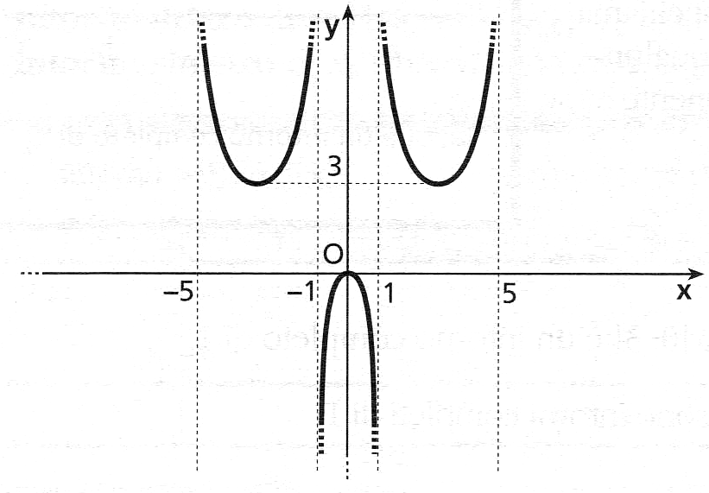 | $$D=\left(−5;−1\right)∪\left(−1;1\right)∪\left(1;5\right)$$  $$\underset{x→−5^{+}}{\text{lim}}f(x)\text{=+}∞$$  $$\underset{x→−1^{−}}{\text{lim}}f(x)\text{=+}∞$$  $$\underset{x→−1^{+}}{\text{lim}}f(x)=−∞$$  $$\underset{x→1^{−}}{\text{lim}}f(x)=−∞$$  $$\underset{x→1^{+}}{\text{lim}}f(x)\text{=+}∞$$  $$\underset{x→5^{−}}{\text{lim}}f(x)\text{=+}∞$$
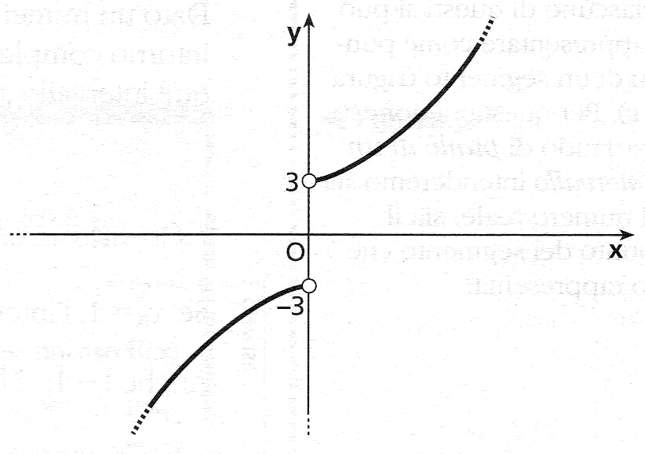 | $$D=\left(−∞;0\right)∪\left(0;+∞\right)$$  $$\underset{x→−∞}{\text{lim}}f(x)=−∞$$  $$\underset{x→0^{−}}{\text{lim}}f(x)=−3$$  $$\underset{x→0^{+}}{\text{lim}}f(x)=3$$  $$\underset{x→+∞}{\text{lim}}f(x)\text{=+}∞$$
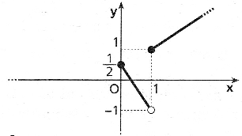 | $$D=[0;+∞)$$  $$\underset{x→0^{+}}{\text{lim}}f(x)=\frac{1}{2}$$  $$\underset{x→1^{−}}{\text{lim}}f(x)=−1$$  $$\underset{x→1^{+}}{\text{lim}}f(x)=1$$  $$\underset{x→+∞}{\text{lim}}f(x)\text{=+}∞$$

